API Test

Answer These Questions:

1. What is an API? Is API documentation required?

* Application programming Interface is a set of defined rules or processes to establish communication between two different applications.
* API documentation is required to create a developer friendly guide, which describes the API’s endpoint, parameters, request/response structure, and error handling in detail.

1. What are different types of API?

There are four types of API’s

* Open API: Open-source APIs are accessed with HTTP protocol.
* Partner API: To connect Strategic business partners.
* Internal API: Private APIs, intended to improve communication across internal development teams.
* Composite API: Combine multiple data or service APIs, allowing programmers to access several endpoints in a single call.

1. What is REST API?

REST (Representational State Transfer) also known as RESTful API is a set of web API architecture principles.

1. What is the difference between REST API and REST FULL API?

* RSET API stands for Representational State Transfer is a set of constraints for the APIs to work, RESTful APIs are built using REST architecture.
* REST APIs may not strictly follow the REST constraints, whereas the RESTful APIs strictly follow the REST constraints.

1. Which protocol is used to transfer messages?

HTTP (Hyper Text Transfer Protocol) is used to transfer messages using the HTTP methods (GET, POST, PUT, DELETE).

1. What is the common method that specifies how you want to interact with the resource?

HTTP methods are used to interact with the resources.

* Get: to retrieve data from the resource
* Post: to create a new resource
* Put: to update the resource
* Delete: remove resources

1. What are the specific paths of URI? Explain

* Method: Specifies HTTP methods Get, Post, Put, and Delete
* Base URL: Uniform Resource Locator known as web address, starts with http or https
* Resource/ path: Specifies the specific resource or endpoint
* Query parameters: Key value pairs that contain additional data to send to the server

1. What are the most common data types with REST APIs?

* String: An alphabetic sequence of letters or numbers
* Integer: A whole number (positive or negative)
* Boolean: true or false value
* Object: Key-value pairs in JSON format
* Array: A list of values

1. Explain Resource

* Resource is an entity or object represented by the API, and identified using URI. Resources can be entities like: user profiles, product, or an abstract concept like: authentication token.
* Example: For an E-commerce API the resources can be Products, orders, Users, and Shopping cart.

1. Identify resource in the screen

* /users/self/follows
* /users/self/followed-by
* /users/self/requested-by
* /users/user-id/relationship
* /users/user-id/relationship

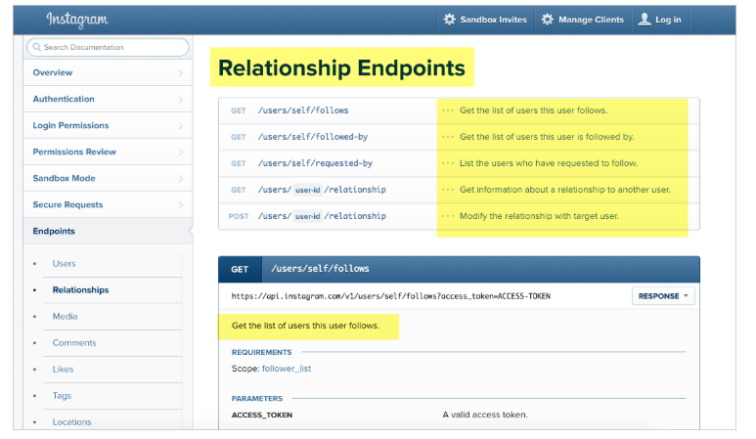

1. What is Endpoint and Method?

* Endpoint specifies the way of accessing the resources, whereas the methods are the interactions used to access the information from resources.

1. What are the functions of these Methods?

* Get: To retrieve data from the resources
* Post: To create the resource
* Put/Patch: to update the resource
* Delete: To remove the resource

1. What are Parameters? What are the four types of Parameter?

Parameters are the options passed with endpoint to influence the response.

Four types of parameters are:

* Header parameter
* Path parameter
* Query string parameter
* Request body parameter

1. What is Schema? What does it provide?

Schema refers to a protocol or protocol identifier defines the client communication with server.

It defines:

* The protocol for communication
* How the server is accessed
* Type of operations used
* Security configurations

1. What are Nested objects?

Nested objects are an object that is a property of another object. Nested objects form a hierarchy of data relationships.